WEB701 Assessment One

Xander Crocker

**Table of Contents**

1. Website Brief 4

2. Site Goals 5

2.1 Purpose of website 5

2.2 Short-term goals 5

2.3 Long-term goals 5

2.4 Intended Audience 5

3. Define the User Experience 5

3.1 Audiences 6

3.1.1 Game developers 6

3.1.2 People with Physical and or Cognitive Disabilities 6

3.2 Why will users visit the website 7

3.3 Scenarios and Personas 7

3.3.1 Scenario 1 7

3.3.2 Scenario 2 7

3.3.3 Scenario 3 8

4. Site Content 9

4.1 Content List 9

4.1.1 Home Page 9

4.1.2 Events Page 9

4.1.3 Learning Page 9

4.1.4 Login and Registration Page 9

4.1.5 Account Page 9

4.2 Functional Requirements 9

4.2.1 Login 9

4.2.2 Register 10

4.2.3 Book a ticket 10

4.2.4 Create an event 10

4.2.5 Change account details 10

4.3 Metaphors 10

4.3.1 Organisational 10

4.3.2 Functional 10

4.3.3 Visual 11

4.4 Structure List 11

4.5 Navigation 12

6. Visual Design 14

6.1 Mock-ups 14

6.2 User Stories 16

6.3 Backlog List 16

7. CRUD analysis / API prototype 18

7.1 CRUD Tables 18

# 1. Website Brief

The Access Games is a community-based charity that offers information on accessibility within the game development industry and provides social events for those with disabilities using video games as a medium.

The charity needs a new website for the Nelson region so that members of the charity can provide services and host events.

The purpose of the new website is to spread awareness and provide a space to host events and provide services to the game development community. The website will let members register and give details on the services and events they are providing.

The website lets members of the community access the service; members are then able to attend events by purchasing tokens. To achieve this goal, the website should have an online token function on our website that will let a beneficiary access a limited number of tokens when hosting an event, for example, the system needs a mechanism that verifies that a member of the community is accessing the service and that the token belongs to a particular community member.

**We require the following features on the website:**

1. Charity members and beneficiaries can register, login and administer their own accounts.

2. Members use the website to register their products and services, and beneficiaries use the system to acquire tokens.

3. Interactive element(s) that engages the website user.

4. The system provides an interface that the members can use to accept a token in a transaction.

# 2. Site Goals

## 2.1 Purpose of website

The goal of this website is to provide a non-profit service to game developers sharing the importance of accessibility in video game design and create opportunities for those with disabilities to share social experiences using video games as a medium. This helps to combat social isolation and creates communities that improve the quality of life for those with disabilities.

## 2.2 Short-term goals

* Inform game developers about the importance of accessibility in video games.
* Reveal and discover barriers to facilitate accessible player experiences.
* Enable social experiences for people with disabilities.

## 2.3 Long-term goals

* Prevent the social isolation of those with disabilities using video games as a medium.
* Foster communities and forge lifelong relationships.
* Guide and promote an inclusive and accessible video game industry.

## 2.4 Intended Audience

* + - New and established Game Developers.
    - Those with existing physical and mental disabilities.
    - The video games industry.

# 3. Define the User Experience

This website will be used to promote the importance of accessibility by providing its users with information and showing real stories about how lives can be changed by including accessibility within video games. Other than the goal to inform, this website is also a platform for creating and joining communities to provide those with disabilities with social interaction. Over 50% of those with either physical or mental disabilities are likely to be socially isolated.

## 3.1 Audiences

### 3.1.1 Game developers

**Needs -**

The first intended audience I will be focusing on is game developers; this is for the reason of spreading the message to developers in the industry, new or existing. Those who have less experience with people who have disabilities may not think of applying accessibility standards to accommodate their needs. I felt the same at one point, but now knowing why these standards exist and how necessary they are, I am a better developer for it.

**Goals -**

The goal is to try to inform game developers to be more inclusive when creating video games. By informing as many developers as possible those who would not normally be able to play games have a chance to experience what the developers have created. This in turn can create communities that would without the incorporation of accessibility may never experience.

**Summary -**

This audience can be somewhat blind to certain things due to being too close to the project or focused on delivering what they are imagining. For this reason, some developers often forget to include inclusive features in their games which excludes a large proportion of people who without these features will never experience what these developers have created.

### 3.1.2 People with Physical and or Cognitive Disabilities

**Needs**

Often people who have disabilities are generally more socially isolated. This can be for many reasons, however, there are several ways to combat their social isolation. I aim to create this website not only to inform developers about the reasons why their games should include accessible features for people with disabilities but also to create communities for people with disabilities where they can share their experiences while enjoying playing video games.

**Goals**

The goal is to bring people together to create long-lasting friendships and lasting memories for those who generally wouldn’t have the necessary exposure to do so. As humans we need to socialize, we need it for many reasons, however, for those suffering from social isolation, it is imperative for good mental health.

**Summary**

Because this audience generally struggles in their daily lives, I want to create a space where they can feel safe and included while sharing their enjoyment of playing video games.

## 3.2 Why will users visit the website

- It's informative to game developers, caregivers, and parents.

- The website provides social experiences through events.

- Developers wanting to reach an audience they may have never thought about before.

## 3.3 Scenarios and Personas

### 3.3.1 Scenario 1

Lewis is a teen in his final days of college and has been inspired by one of his teachers to create a small game for a game jam event to show off what he can do. In doing so, Lewis started looking into ways he could develop his idea, researching development processes and anything he may not have thought about prior.

Lewis in his research comes across a list of things he should consider when designing his game. When reading through the list, Lewis notices the section labelled Accessibility. Not quite knowing or understanding why he should include accessibility in his game, he decides to search for what accessibility in video games involves. During his search, Lewis comes across the Access Games website continues to the learning page and scrolls through the contents. After reading the contents Lewis now sees the reasoning and importance of incorporating accessibility into his games.

### 3.3.2 Scenario 2

A developer by the name of Jane has started working for a medium-sized video game company. On the first project she was assigned to, she realised that in the design documentation, there was minimal information in the accessibility section. This seemed odd to her considering she has a physically disabled younger brother, and her brother relies on controller functionality to play games.

In her confusion, Jane then brings this up with the team leader and expresses her concerns on the matter. She explains that without the inclusion of controller functionality people with similar conditions to her brother can’t remap the controls to specialized devices that allow them to play the game.

Immediately Jane shows the team leader the Access Games website that she found out about through one of her brother’s caregivers. She explained that her brother found a community through the website by going to events and finding out ways that her brother could play games when her family thought it impossible to. This established the importance in the team leader's mind that including more accessibility within their game was not only necessary but could place a barrier between the developers and players.

Through the website, the team leader learns what changes need to be made to make the game more inclusive to their audience.

### 3.3.3 Scenario 3

Jim and his wife Mary have a daughter, Stacy who was born with a cognitive disability and they want to find a community for their daughter to have more social interaction.

After searching around online for a local community for those with disabilities Jim came across the Access Games website and navigated to the events page. From here Jim sees that there are plenty of events that his daughter can attend all surrounding the playing of video games. Immediately Jim discusses the idea with Mary and Stacy. Stacy was very excited about the idea.

Jim then goes back to the website then navigates to the login page and using the registration button creates an account with Access Games. Once the account is registered, Jim navigates back to the events page to find a suitable event to attend.

To get a ticket Jim clicked on the specific event and clicked the book a ticket button located to the right of the event details. Once clicked a ticket is issued to the account and Jim, Mary, and Stacy are booked in to attend the event.

# 4. Site Content

## 4.1 Content List

### 4.1.1 Home Page

The home page will open with a slideshow displaying images from previous events. Below will be cards displaying user stories about learning to include more accessible features within games and experiences people have had due to the events listed on the website.

### 4.1.2 Events Page

The events page will have a grid of cards giving a description of the event and a few details such as location and time as well as a book now button. Each card can be clicked which will show a pop-up with more details on the event and a button to book a ticket. At the top of this page, there will be a button where a user can create an event card for an event the user is hosting.

### 4.1.3 Learning Page

The learning page will have several sections of information referring to accessibility within video games. Such sections will include, how to apply better accessibility, what can be done at home, devices that may be useful, and more.

### 4.1.4 Login and Registration Page

This page will allow users to log in to the website by inputting their email and password and clicking the login button. If a user wants to register an account, they need to navigate to the login page and click the register button. From here the user will need to input the required details and click the register button. The user will then be navigated back to the login page to enter their details.

### 4.1.5 Account Page

Once logged in a user will be able to navigate to this page via the navigation bar to see the details of their account and view any ticked, they have booked. From this page, the logged-in user can change any of their details.

## 4.2 Functional Requirements

### 4.2.1 Login

There must be a way for a user to log in to their accounts. Users can log in by navigating to the login page via the navigation bar. For a user to log in a user must have an existing account. From the login page, the user must enter their email address and password. A logged-in user has more functionality than a user who has no registered account. This will include creating an event or booking a ticket to an existing event.

### 4.2.2 Register

There must be a way for a user to register an account with the website. Users can register an account by navigating to the login page via the navigation bar and clicking the register button. To register the user must enter their details such as name, email address, and password.

### 4.2.3 Book a ticket

Users must have a way to book a ticket. A ticket can only be booked by a user who is logged in to the Access Games website. To view a ticket that has been booked the user can navigate to the account details page via the navigation bar.

### 4.2.4 Create an event

Users must have an account with the Access Games website and will have to have certain permissions to do so. Permissions can be assigned by applying on the account details page.

### 4.2.5 Change account details

A user must have a way to change their account details. A user who is logged in can do this by navigating to the account details page via the navigation bar. Once there the user can click the update details button. The user will then be directed to a page that will allow them to change their details such as name, email, and password.

## 4.3 Metaphors

### 4.3.1 Organisational

The website will need to have a clean layout with plenty of room for users to increase the size of the contents. To achieve this, elements will have a reasonable amount of space between each other with a padded margin. This way nothing is cluttered and cannot clash. The colour scheme will need to be welcoming to the users, creating a warm, caring, yet informative environment.

### 4.3.2 Functional

Depending on the user’s reasons for visiting the website would affect what functional metaphor would apply. The first is a developer wanting to learn; often navigating to the learning section of the website and reading through the structured sections of content. The second would be a user wanting to attend an event in which case, the users would navigate to the events page and view a grid of event cards. Users can then select an event to book a ticket if they wish.

### 4.3.3 Visual

Using the colour scheme, I want to create a feeling of comfort to the user. The colours should be warm and inviting, not jarring or overwhelming. To do this I will use pastel colours to accentuate elements of the contents.

## 4.4 Structure List

**Home**

* Header / Navigation Bar
  + Home
  + Learning
  + Events
  + Login
  + Account Details
* Slideshow
* Charity Information
* User Stories
* Footer

**Login**

* Header / Navigation Bar
  + Home
  + Learning
  + Events
  + Login
  + Account Details
* Login Form
* Footer

**Registration**

* Header / Navigation Bar
  + Home
  + Learning
  + Events
  + Login
  + Account Details
* Registration Form
* Footer

**Events**

* Navigation Bar
  + Home
  + Learning
  + Events
  + Login
  + Account Details
* Grid of Event cards
* Event card popup (when clicked)
* Footer

**Learning**

* Header / Navigation Bar
  + Home
  + Learning
  + Events
  + Login
* Development Section
* Hardware Section
* Footer

**Account Details**

* Header / Navigation Bar
  + Home
  + Learning
  + Events
  + Login
  + Account Details
* Account details card (displaying the user’s information)
* Ticket List (showing any tickets that have been booked)
* Footer

## 4.5 Navigation

From the top of any page, the user can navigate through the website via the Navigation bar. The navigation bar holds the following pages.

* Home
* Learning
* Events
* Login
* Account Details

The website needs to have a simple way to navigate making it inviting not confusing. As a user, I would like to view the content I want as soon as possible, or I would try to find what I am looking for somewhere else.

# 6. Visual Design

## 6.1 Mock-ups

**Home**

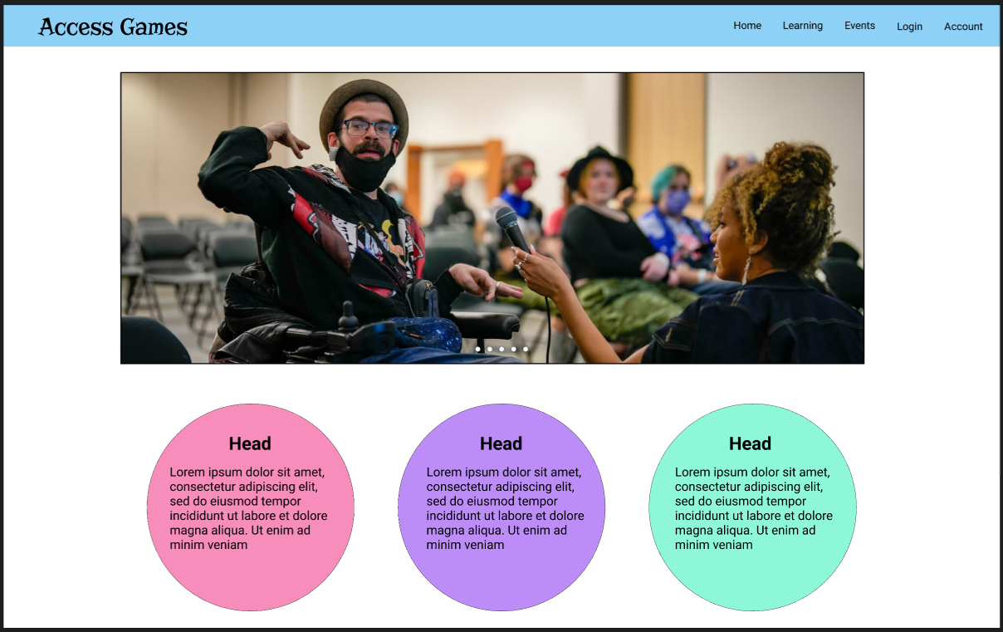

**Login**

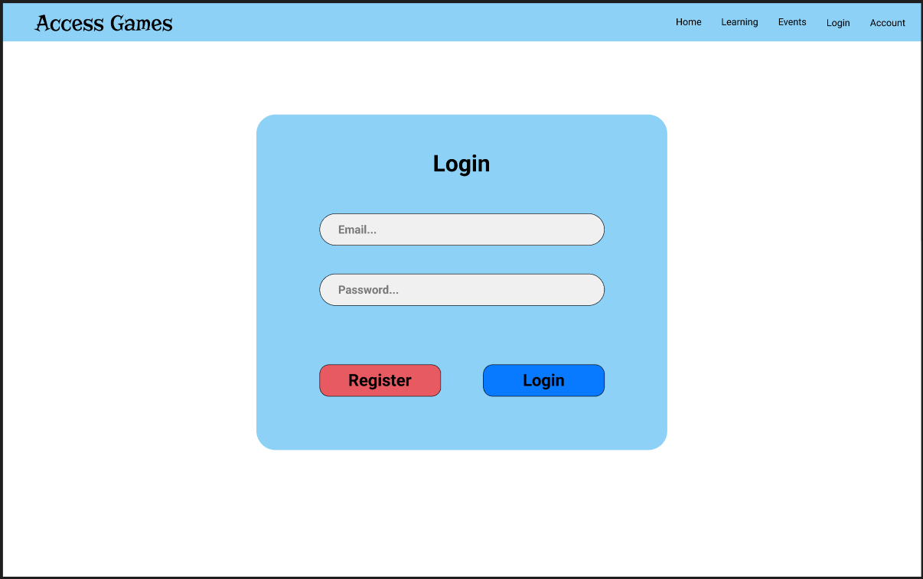

Events

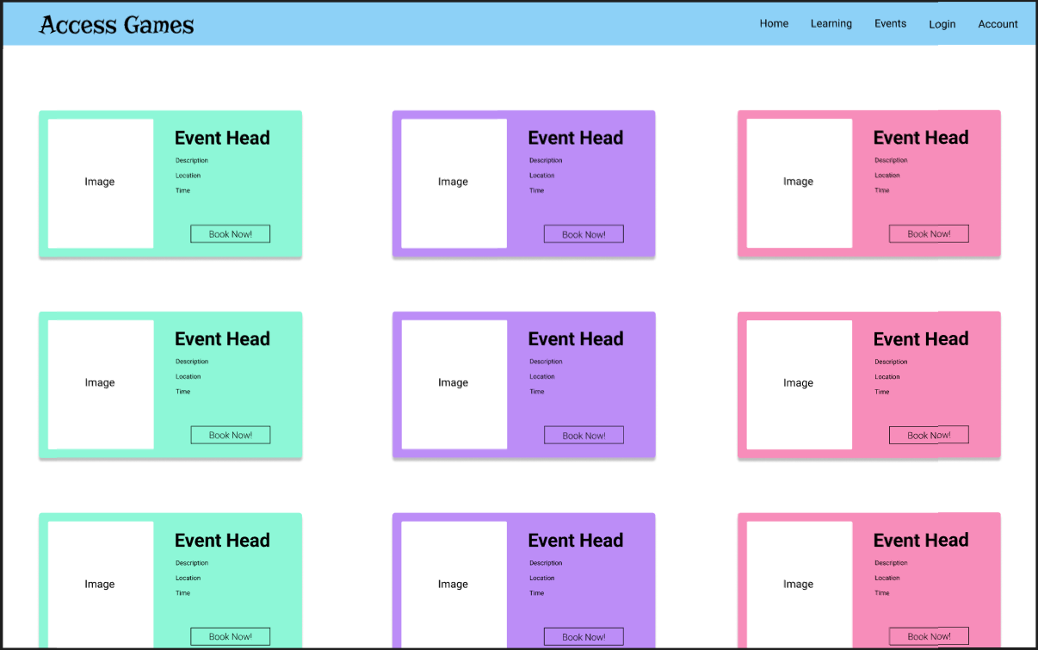

Learning

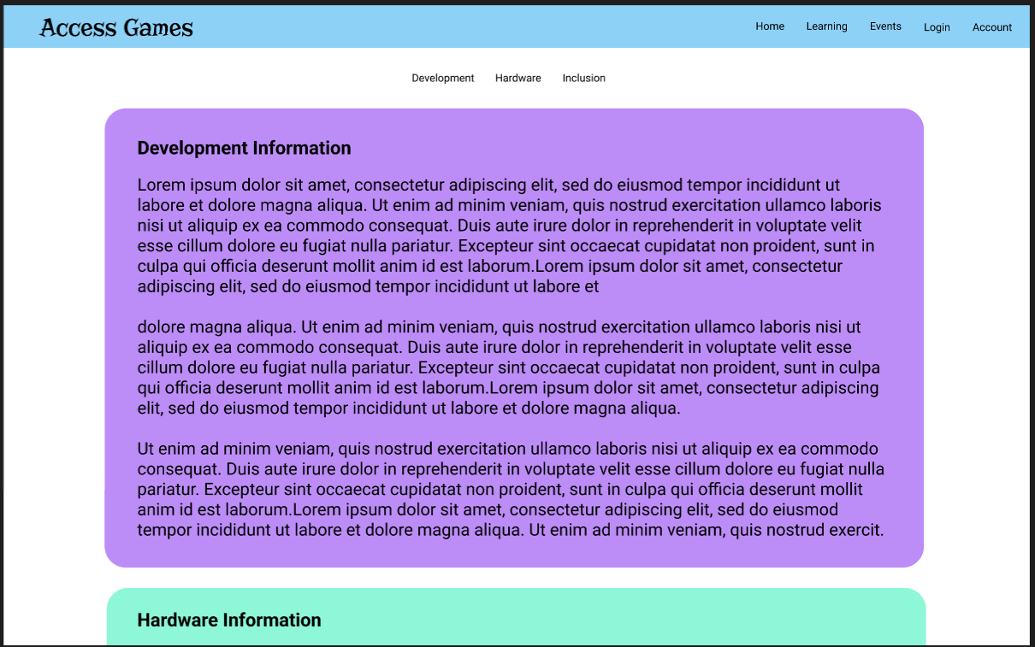

## 6.2 User Stories

**Register an Account**

As Jimmy,

I want to register an account with Access Games,

So I can book a ticket to an event.

**Login to an Account**

As Sarah,

I want to log into my account,

So I can view my booked tickets.

**Change Account Details**

As Jenny,

I want to change my password,

So I protect my account with Access Games.

**Book a ticket to an Event**

As Matt,

I want to book a ticket to an event,

So that I can attend an event.

## 6.3 Backlog List

- Login

- Registration

- Navigation bar

- Event card list

- Book a ticket to an event

- Viewing booked tickets

- MongoDB database

- React Frontend

- Express Backend

- Development Information

- Hardware Information

- Slideshow Images

- User Story Images

- Informative Images

# 7. CRUD analysis / API prototype

## 7.1 CRUD Tables

**Register**

|  |  |  |  |  |  |  |
| --- | --- | --- | --- | --- | --- | --- |
| Process | ID | FirstName | LastName | Email | Password | Ticket |
| Registration | C | C | C | C | C | C |

**Login**

|  |  |  |  |  |  |  |
| --- | --- | --- | --- | --- | --- | --- |
| Process | ID | FirstName | LastName | Email | Password | Ticket |
| Login | R | R | R | R | R | R |

**Obtain Ticket**

|  |  |  |  |  |  |  |
| --- | --- | --- | --- | --- | --- | --- |
| Process | ID | FirstName | LastName | Email | Password | Ticket |
| Obtain Ticket | R | R | R | R | R | RU |

**Modify Account Details**

|  |  |  |  |  |  |  |
| --- | --- | --- | --- | --- | --- | --- |
| Process | ID | FirstName | LastName | Email | Password | Ticket |
| Registration | R | RU | RU | RU | RU | R |